**Streamlining Ticket Assignment for Efficient Support Operations**

**Team Id : NM2025TMID18218**

**Team Leader: KAMAL M**

**Team Member1: MAGESH B**

**Team Member2: SATHISH KUMAR P**

**Team Member3:** THARUN P

**Problem Statement:**

In a compact project team comprising Alice, the Project Manager, and Bob, a Team Member, the absence of structured ticket-handling processes leads to confusion and inefficiency. The current setup lacks defined roles and access controls, meaning task ownership is unclear and permissions are inconsistently enforced. Without a formal ticket assignment workflow or escalation plan, tasks may stagnate or become misdirected, resulting in delays and diminished accountability. Additionally, the lack of categorization, prioritization, and reporting mechanisms hinders visibility into progress, making it difficult to monitor task status or measure performance effectively.

**Objective:**

**1.Clearly Define User Roles:** Establish well-defined roles for Alice (Project Manager) and Bob (Team Member) to eliminate role confusion, ensure accountability, and provide a clear structure for responsibilities within the project management system.

**2.Implement Robust Access Controls:** Introduce role-based access restrictions that allow Bob to view and update only his assigned tasks while preventing him from creating or modifying projects. This safeguards project integrity and minimizes the risk of unauthorized changes.

**3.Optimize Workflow Processes:** Develop a streamlined workflow that enables Alice to assign tasks seamlessly to Bob, track his progress in real time, and monitor task completion. This ensures efficiency, transparency, and timely resolution of project-related activities.

**Skills:** Users, Groups, Roles, Table, Assign Roles & Users To Groups, Assign Role To Table, Create ACL, Flow

**TASK INITIATION**

**Milestone 1: Users**

**Activity 1 : Create Users**

1. Open service now.
2. Click on All  >> search for users
3. Select Users under system security
4. Click on new
5. Fill the following details to create a new user

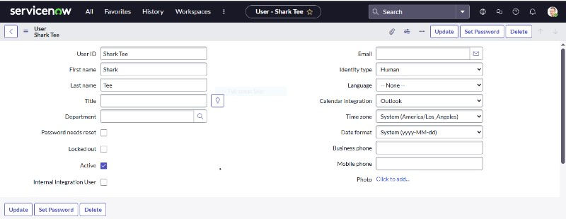  
6. Click on submit  
**Create one more user:**

7. Create another user with the following details  
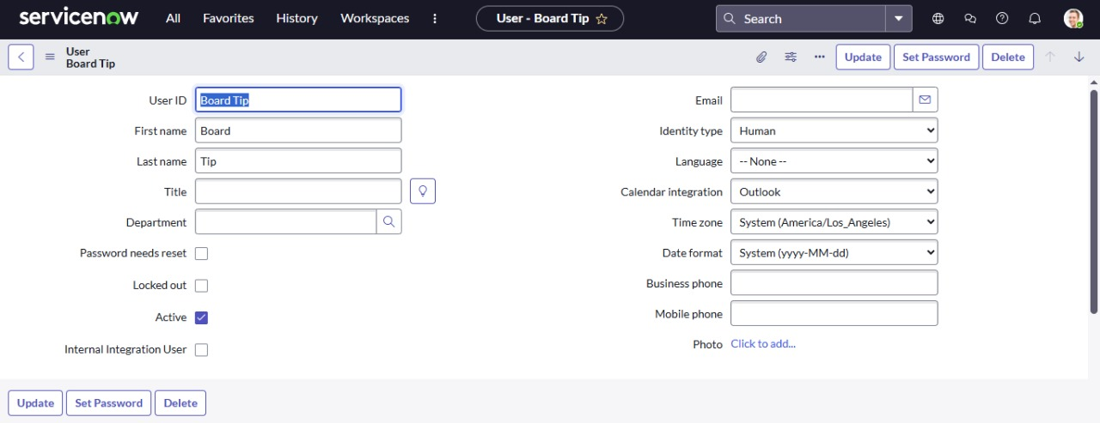

1. Click on submit

**Milestone 2: Groups**

**Activity 1 : Create Groups**

1. Open service now.
2. Click on All  >> search for groups
3. Select groups under system security
4. Click on new
5. Fill the following details to create a new group

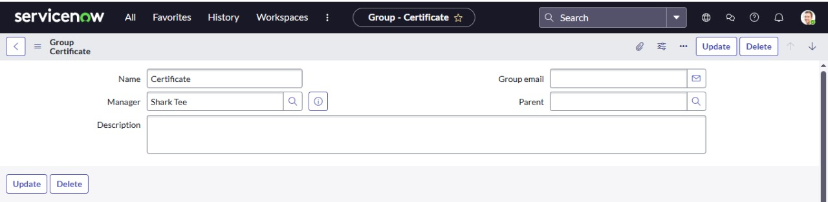

1. Click on submit

**Create one more group:**

1.Create another group with the following details

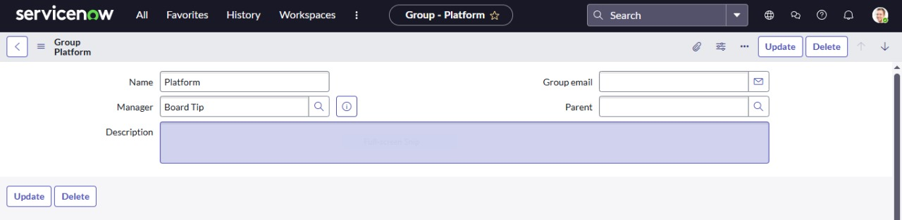

1. Click on submit

**Milestone 3: Rules**

**Activity 1 : Create Rules**

1. Open service now.
2. Click on All  >> search for roles
3. Select roles under system security
4. Click on new
5. Fill the following details to create a new role

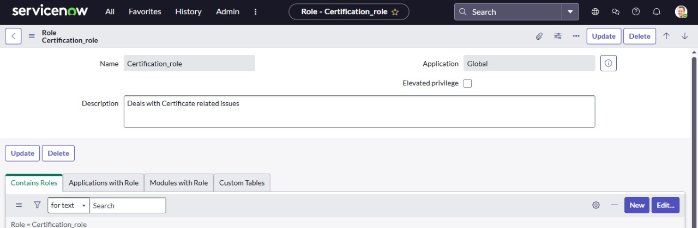  
6. Click on submit

Create one more role:

Create another role with the following details

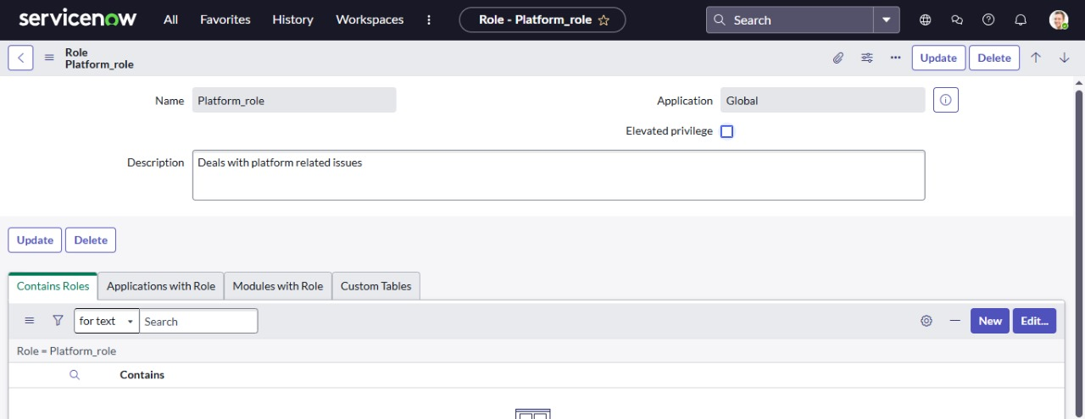

Click on submit

**Milestone 4:Assign Role To Table**

**Activity 1 : Create Assign Role To Table**

1. Open service now.
2. Click on All  >> search for tables
3. Select operations related table
4. Click on the Application Access
5. Click on u_operations_related read operation
6. Click on the profile on top right side
7. Click on elevate role
8. Click on security admin and click on update
9. Under Requires role
10. Double click on insert a new row
11. Give platform role
12. And add certificate role
13. Click on update

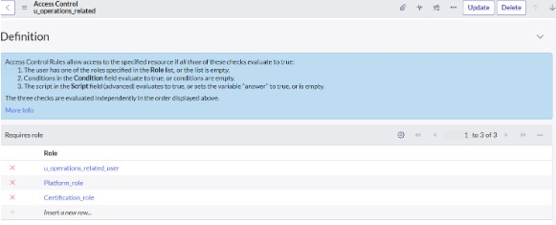

1. Click on u_operations_related write operation
2. Under Requires role
3. Double click on insert a new row
4. Give platform role
5. And add certificate role

**Milestone 5:Create ACL**

**Activity 1 : Create ACL**

1. Open service now.
2. Click on All  >> search for ACL
3. Select Access Control(ACL) under system security
4. Click on new
5. Fill the following details to create a new ACL

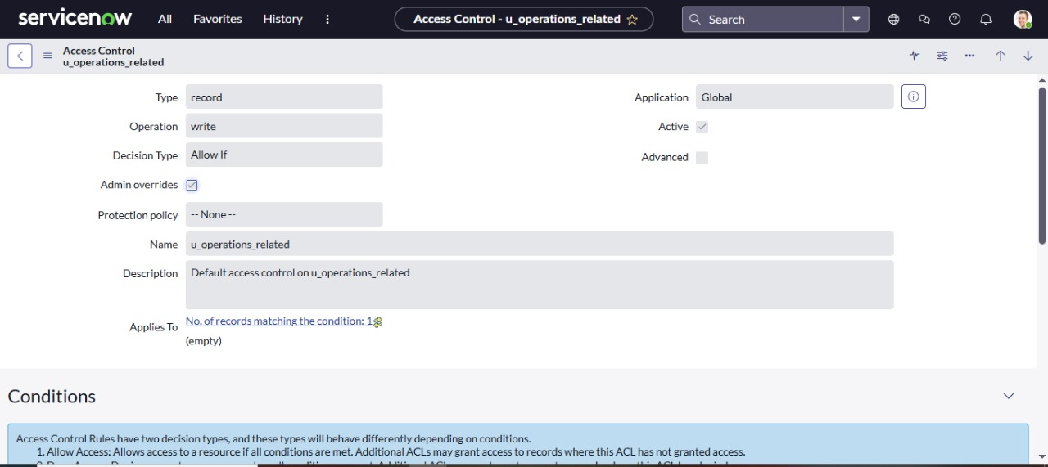

1. Scroll down under requires role
2. Double click on insert a new row
3. Give admin role
4. Click on submit
5. Similarly create 4 acl for the followingfields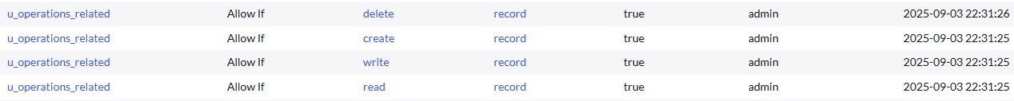

**Milestone 6: Flow**

**Activity 1 :Create a Flow to Assign Operations Ticket To Group**

1. Open service now.
2. Click on All  >> search for Flow Designer
3. Click on Flow Designer under Process Automation.
4. After opening Flow Designer Click on new and select Flow.
5. Under Flow properties Give Flow Name as “ Regarding Certificate”.
6. Application should be Global.
7. Select Run user as “ System user ” from that choice.
8. Click on Submit.

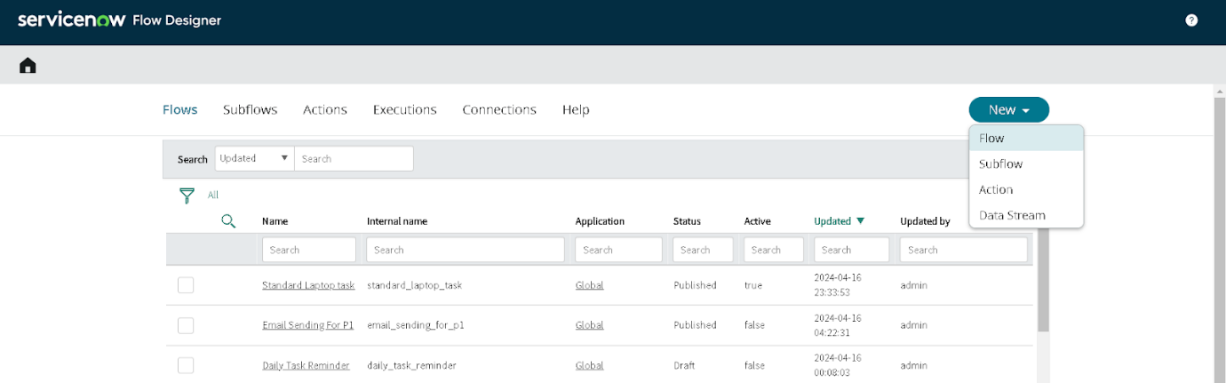

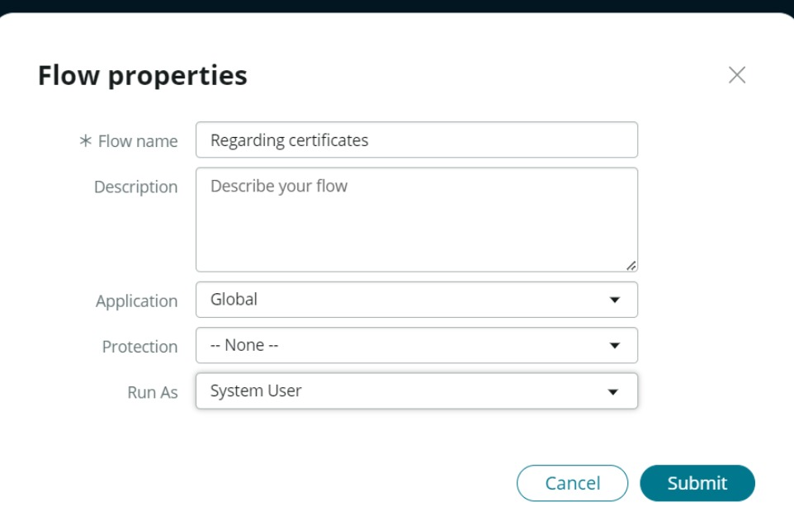

1. Click on Add a trigger
2. Select the trigger in that Search for “create or update a record”  and select that.
3. Give the table name as “ Operations related ”.
4. Give the Condition as

Field: issue

Operator: is

Value: Regarding Certificates

1. After that click on Done

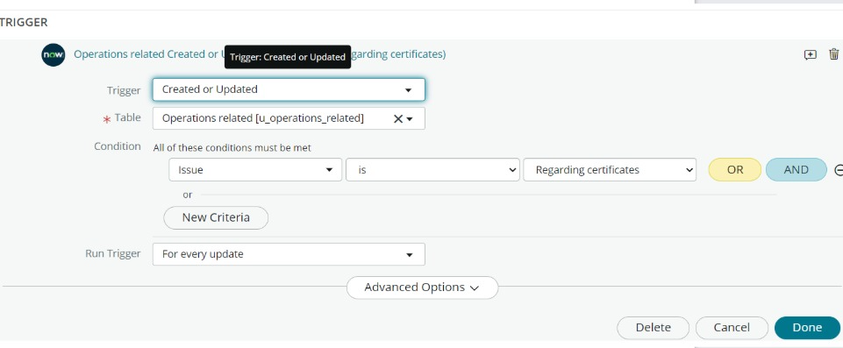

1. Now under Actions.
2. Click on Add an action.
3. Select action in that search for “ Update Record ”.
4. In Record field drag the fields from the data navigation from left side
5. Table will be auto assigned after that
6. Give the field as “ Assigned to group ”
7. Give value as “ Certificates ”
8. Click on Done.
9. Click on Save to save the Flow.
10. Click on Activate.

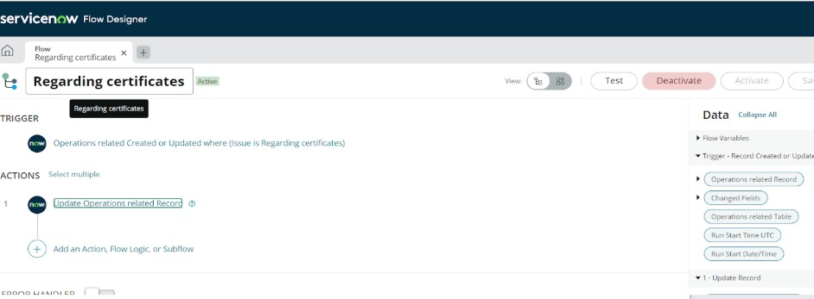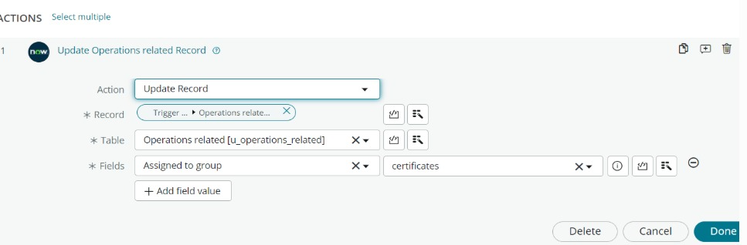

**Activity 2 :Create a Flow To Assign Operations Ticket To Platform Group**

1. Open service now.
2. Click on All  >> search for Flow Designer
3. Click on Flow Designer under Process Automation.
4. After opening Flow Designer Click on new and select Flow.
5. Under Flow properties Give Flow Name as “ Regarding Platform ”.
6. Application should be Global.
7. Select Run user as “ System user ” from that choice.
8. Click on Submit.
9. Click on Add a trigger
10. Select the trigger in that Search for “create or update a record”  and select that.
11. Give the table name as “ Operations related ”.
12. Give the Condition as

Field: issue

Operator: is

Value: Unable to login to platform

1. Click on New Criteria

Field: issue

Operator: is

Value: 404 Error

1. Click on New Criteria

Field: issue

Operator: is

Value: Regarding User expired

1. After that click on Done.
2. Now under Actions.
3. Click on Add an action.
4. Select action in that search for “ Update Record ”.
5. In Record field drag the fields from the data navigation from left side
6. Table will be auto assigned after that
7. Give the field as “ Assigned to group ”.
8. Give value as “ Platform ”.
9. Click on Done.
10. Click on Save to save the Flow.
11. Click on Activate.